This section is from the book "Clothing And Health. An Elementary Textbook Of Home Making", by Helen Kinne. Also available from Amazon: Clothing And Health.

The Story Of How Wool Is Made Into Cloth
The Pleasant Valley boys and girls learned how wool is made into cloth after it has been sheared from the sheep. Would you like to know ?
First, the wool is sorted. Wool sometimes travels a long distance before it is delivered to the manufacturer. Perhaps the wool in your skirt was grown in England or in Australia, and was shipped in great sacks to New York, and then to the manufacturer. As it is sheared from the sheep, it is dirty and full of burrs, grease, and perspiration. This grease helps to preserve the wool until the manufacturer is ready to use it; and, although he buys the wool by weight and pays for dirt and grease, he prefers to do so because of the preserving qualities of the grease. Even 2/3 of the weight may be dirt and grease. The first thing the manufacturer does is to sort the wool to put the good grades together, and to separate them from the poor ones. You remember the fleece is the whole coat of the sheep. Some parts of this coat are better wool than others; especially the part from the head and upper part of the back and sides. About seven different grades are separated for different purposes.
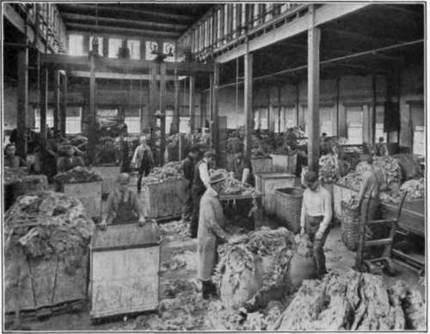
Courtesy of M. J. Whtttall.
Fig. 120. - Wool sorting.
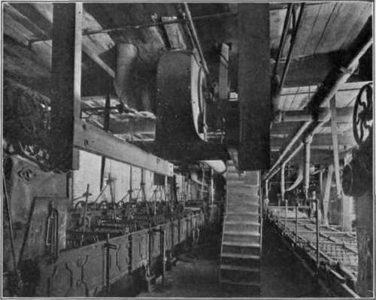
Courtesy of M.J. Whittall.
Fig. 121. - Wool washing or scouring.
The second process is washing or scouring. Wool cannot be carded and spun until the dirt and grease are removed; so the next thing the manufacturer does is to remove the grease, or "yolk" as it is called, by washing. This must be done very carefully so as not to break or injure the wool. Perhaps you can bring some dirty wool from your farm to school and wash it. Soft soap is the most harmless. Use a soft water at a low temperature (1200 F.). Can you tell why it must be low? The washing is done in a series of tanks. You can see them in the picture (Fig. 121). The wet wool is swished back and forth by means of wooden forks which carry the wool forward and beat it out. There are rollers for passing the wool from one tank to another. Then the wool must be dried. This is done in a kind of wringing machine called a "hydro extractor." Then it is beaten into a fluffy mass.
Then a strange thing happens. Oil in wool is necessary in order to help in the spinning and to keep it soft and elastic, so the manufacturer must return some oil to the wool, after having washed it all out. Olive oil is used.
If there is any dirt or any burrs left in the wool, they must be removed. A machine called a burr picker is used to beat out the dirt.
Then the wool is blended. Do you know that the wool skirt which you are wearing may not be made of all new wool? Wool can be used over and over again. Old wool rags are pulled apart and mixed with new wool. If this did not happen, the manufacturer would have to charge much more than you pay for serge or some woolen materials, as he would have to use all new wool. That is why some wool materials are so expensive. If only new wool were used, there would not be enough raised in the world to clothe everybody. The wool manufacturer, therefore, blends, or mixes, the wool before it is sent to the carding machine. In blending he knows just what color, style, and grade of material he wishes to produce, and he grades accordingly. Cheapness is one of the principal reasons for blending. Sometimes cotton or jute are mixed in, if the manufacturer wishes to produce a very cheap material which is not all wool.
Would you like to know the names of some of the all-wool substitutes which are used in reducing the cost of all-wool materials? Marjorie Allen's grandmother told her, and Marjorie told the League girls. Shoddy is one; it is made from old rags, like woolen stockings, flannels, soft underwear; materials which have not been felted together. Do you know what felted means?
The rags are washed, ground up, and prepared to mix with the new wool. Mungo is another queer name which is given to woolen rags which have been felted, as broadcloth or men's suitings. Flocks is nothing but dust or waste from the clipping machines when cloth is sheared or clipped in finishing. This is used to fill in. So you see nothing is wasted.
The next process after blending is carding. Do you remember how cotton is carded? Long ago, when Marjorie's grandmother was young, wool was carded by hand. Look at the picture on page 77 and see how Grandmother Allen holds the cards. She is preparing rolls of wool for the spinning wheel. The manufacturer must prepare the slivers, or rolls like ropes of wool, for the spinning frames as they are called to-day. The machine which helps to produce these ropes is called the carding machine. It also helps to clean the dirt from the wool. The picture (Fig. 122) will show you how the wool carder looks. There is a center cylinder and around it revolve small cylinders. They are all covered with wire teeth which help to pull the wool apart and to cleanse it. If you were to stand before the machine, you would see a gauzy, filmy sheet of wool the width of the long rollers as it leaves the machine.
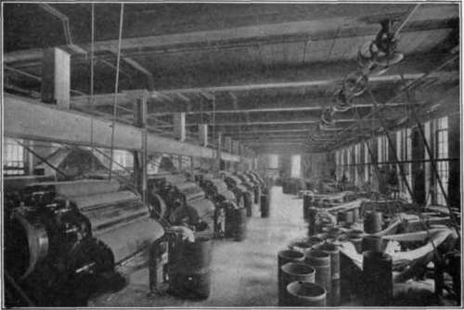
Courtesy of M.J. Whittall.
Fig. 122. - Wool carding. Notice the round cylinders. The gauzy web is being delivered into the can in front of the carding machine.
The wide guazy mass is pulled together as it is drawn through a hole at the front of the carder and is delivered or wound up in the can, just as we learned the cotton was delivered. This wool roving is then wound on spools and is ready for spinning. Do you remember the story of how cotton is drawn out and twisted and wound on spools? Wool too must be spun and made into yarn, before yarn can be woven into cloth. The manufacturer makes woolen yarn and also worsted yarn. Do you know the difference? We shall study in our next lesson about them.

Exercises And Problems
1. Ask your grandmother to tell you about sheep raising on the farm, when she was a girl.
2. Tell why the manufacturer must blend old and new wool. What are the names of some old rags of wool used for this purpose ?
3. Tell how carding was done in olden times. How is wool carding done to-day? Why is carding an important process in the manufacture of cloth made from wool?

Continue to:
- prev: Lesson 4. Making A Pair Of Bloomers Let Us Begin To Make The Bloomers To-Day
- Table of Contents
- next: Lesson 6. Some Facts To Remember In Purchasing Wool Clothing

